Operational Amplifier

# 1. Voltage gain versus frequency for an inverting amplifier

Measure the voltage gain v = Uout / Uin for an inverting amplifier in the frequency range of 1kHz to 2MHz for three different gains of 1, 10 and 100. R1 is constantly 1kW and the input voltage is 100mV. The gain is to be shown in a logarithmic scale as well as the frequency.

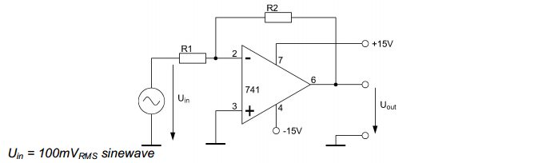

In this first measurement we want the frequency-dependent behavior of an inverting amplifier for 3 different gains. From the resulting curves in each case the gain-bandwidth product is then determined.

The gain of this amplifier is $Vu= \frac{Ua}{Ue}= -\frac{R2}{R1}$

It follows that we can achieve the abandonment of the three different gains by the appropriate choice of resistors. R1 is for all measurements 1 K.OMEGA

$$40dB=20*log*\left(\frac{Ua}{Ue}\right)$$

$$2=log*\left(\frac{Ua}{Ue}\right)$$

$$10^{2}= \left(\frac{Ua}{Ue}\right)$$

$$100= \left(\frac{R2}{1kΩ}\right)$$

$$R2=100 kΩ$$

**20 dB: 10 kΩ**

**0dB: 1 kΩ**

The input voltage, we provide a to a level of -20 dB. This means

$$-20=20*log*\left(\frac{Ue}{0,775V}\right)$$

$$1^{-1}=(\frac{Ue}{0,775V})$$

$$Ue=77,5 mV$$

**Measurements :** **In order to display the voltage curves, we measure the input and output levels in dB for different frequencies. Is considered separately, the limit frequency at which the gain falls to -3 dB.**

|  |  |  |  |
| --- | --- | --- | --- |
| Vu in db | 1 kΩ | | |
| input voltage | Output voltage | amplification |
| 1 kHz | -20 | -20 | 0 |
| 10 kHz | -20 | -20 | 0 |
| 100 kHz | -20 | -20 | 0 |
| 1 MHz | -20 | -24 | -4 |
| fg (-3dB) | 0,92 MHz | | |
|  |  |  |  |
| Vu in db | 10 kΩ | | |
| input voltage | Output voltage | amplification |
| 1 kHz | -20 | 0 | 20 |
| 10 kHz | -20 | 0 | 20 |
| 100 kHz | -20 | -4 | 16 |
| 1 MHz | -20 | -20 | 0 |
| fg (-3dB) | 96 kHz | | |
|  |  |  |  |
| Vu in db | 100kΩ | | |
| input voltage | Output voltage | amplification |
| 1 kHz | -20 | 20 | 40 |
| 10 kHz | -20 | 17 | 37 |
| 100 kHz | -20 | -0.5 | 19.5 |
| 1 MHz | -20 | -20 | 0 |
| fg (-3dB) | 10 kHz | | |

# 2. Slew rate and range of output voltage

Measure the maximum velocity of rise of output voltage (slew rate) and the range of output

voltage using an oscilloscope. For this measurement the amplifier has to be overdriven.

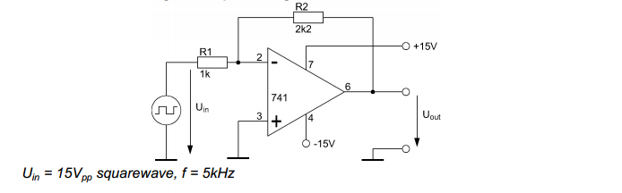

In this experiment, we want to measure the Slew- rate of OPV, the maximum slew rate of the output voltage when the input voltage changes abruptly. For this sudden change, we generate a square wave signal and pass it to the input.

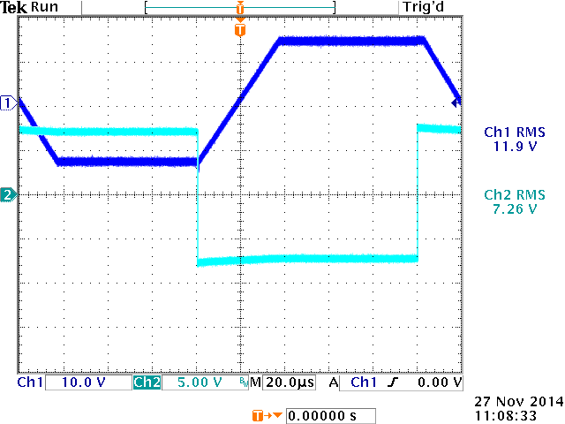

Figure 1: Input signal (db) and output (hb)

The Slew- rate is now the time that elapses until the output has increased from 90% of its low level to 90% of its high level. In our experiment, we measured an increase of 22.2 V to 27.6 microseconds. This means a Slew- rate of about 0.8 V / us. The datasheet of the OPVs indicates a value of 0.5 V / us.

This discrepancy can be explained by the inaccuracies incurred in setting the cursor on the oscilloscope.